A

Synopsis

on

**MULTIMODAL LANGUAGE TRANSLATOR TOOL**

*in partial fulfillment of the requirement for the degree*

of

Bachelor of Technology

In

COMPUTER SCIENCE AND ENGINEERING

Submitted by

**Sanyam Singh Parihar (2201330100235)**

**Vineet Chaudhary (2201330100285)**

**Ayush Pratap Singh (2201330100079)**

**Ashutosh Shukla (2201330100076)**

Under the supervision of

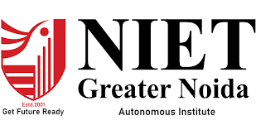

**NOIDA INSTITUTE OF ENGINEERING AND TECHNOLOGY**

**GREATER NOIDA**

**Index**

|  |  |  |
| --- | --- | --- |
| Sr. No. | Topics | Page No. |
| 1 | Introduction | 3-4 |
| 2 | Existing Systems | 5-6 |
| 3 | Problem Statement | 7 |
| 4 | Proposed Methodology | 8-13 |
| 5 | Feasibility Study | 14-16 |
| 6 | Facilities required for proposed work | 17-19 |
| 7 | Conclusion | 20-21 |
| 8 | References | 22 |

Supervisor Sign:

**INTRODUCTION**

In today's globalized world, effective communication across linguistic barriers is crucial for various aspects of life, including business, education, diplomacy, and social interaction. However, the diversity of languages spoken worldwide often presents challenges in achieving seamless communication. Language barriers can hinder collaboration, limit access to information, and impede the exchange of ideas.

In an increasingly interconnected world, effective communication across language barriers is paramount. Our project aims to address this challenge by developing a versatile language translator tool that facilitates seamless interaction between individuals speaking different languages.

The need for such a solution is evident in various domains, including travel, business, education, and diplomacy. Language barriers often hinder collaboration, inhibit access to information, and limit opportunities for cultural exchange. By creating a reliable and user-friendly language translator, we aspire to empower individuals and organizations to overcome these barriers and foster greater inclusivity and understanding in global communication.

Our translator will leverage state-of-the-art natural language processing (NLP) techniques and machine learning algorithms to accurately translate spoken and written text between multiple languages. We envision a system that not only provides literal translations but also preserves contextual nuances and idiomatic expressions to ensure clear and accurate communication.

Key features of our language translator include:

* **Real-time Translation**: Instantaneous translation of spoken conversations, enabling fluid communication between individuals speaking different languages.
* **Text Translation**: Seamless conversion of written text from one language to another, supporting various document formats and online content.
* **Multilingual Support**: Comprehensive coverage of major world languages, with the flexibility to add new languages and dialects based on user demand.
* **Customization Options:** Personalization features to tailor the translation experience according to user preferences, such as preferred languages, dialects, and translation accuracy levels.
* **User-Friendly Interface**: Intuitive interface designed for ease of use across different devices, including smartphones, tablets, and computers.

We will be using HTML, CSS, and JavaScript for front-end development, along with frameworks either of React, Angular, or Vue.js.

For Database Management we will be using MySQL, MongoDB

We will be incorporating libraries or APIs for speech recognition (e.g., Google Cloud Speech-to-Text, Mozilla DeepSpeech) and speech synthesis (e.g., Google Text-to-Speech, Microsoft Speech SDK) for real-time translation of spoken conversations.

Our team is committed to developing a robust and scalable language translator that meets the diverse needs of users across various sectors and regions. By fostering cross-cultural communication and collaboration, we believe that our project will contribute to building a more interconnected and harmonious global community.

**EXISTING SYSTEM**

| **­­­System Name** | **Description** | **Features** | **Languages Supported** | **Availability/Platform** |
| --- | --- | --- | --- | --- |
| Google Translate | A widely-used online translation service | - Supports text translation, website translation, and real-time conversation translation | Over 100 languages, including major world languages | Web, Mobile App  (iOS, Android) |
| Microsoft Translator | Translation service by Microsoft | - Offers text translation, speech translation, and image translation | Supports 70+ languages | Web, Mobile App  (iOS, Android) |
| DeepL Translator | Neural network-based translation service | - Known for high-quality translations with deep learning technology | Supports 26 languages, including major European languages | Web, Desktop App,  API |
| IBM Watson Language Translator | Language translation service powered by IBM Watson | - Provides text translation with support for custom models and domain-specific terminology | Supports 11 languages, with domain-specific customization | Web, API |
| Yandex Translate | Translation service by Yandex | - Offers text translation with options for general, legal, technical, and other specialized translations | Supports 95 languages, including Russian | Web, Mobile App  (iOS, Android) |
| SYSTRAN Translate | Translation software by SYSTRAN | - Provides text translation with support for custom dictionaries, terminology management, and language detection | Supports 55+ languages, including Asian languages | Desktop (Windows, macOS), Web, API |

| **System Name** | **Description** | **Features** | **Languages Supported** | **Availability/Platform** |
| --- | --- | --- | --- | --- |
| Google Neural Machine Translation (GNMT) | Google's NMT system for translation | - Utilizes neural networks for translation, providing more contextually accurate translations | Over 100 languages, including major world languages | Integrated into Google Translate, Web, API |
| OpenNMT | Open-source neural machine translation toolkit | - Flexible and customizable NMT toolkit for researchers and developers | Customizable based on dataset and language pairs | Open-source, can be deployed locally or on cloud |
| Fairseq | Facebook's sequence-to-sequence toolkit | - Developed by Facebook AI Research (FAIR), supports state-of-the-art NMT models | Customizable based on dataset and language pairs | Open-source, can be deployed locally or on cloud |
| MarianNMT | Fast neural machine translation framework | - Known for its speed and efficiency, supports various NMT architectures and training strategies | Customizable based on dataset and language pairs | Open-source, can be deployed locally or on cloud |
| TensorFlow NMT | TensorFlow's official NMT implementation | - Provides pre-trained models and tools for building custom NMT systems using TensorFlow | Customizable based on dataset and language pairs | Open-source, can be deployed locally or on cloud |
| OpenNMT-tf | TensorFlow-based NMT implementation | - Built on TensorFlow, offers tools for training and deploying custom NMT models | Customizable based on dataset and language pairs | Open-source, can be deployed locally or on cloud |

**PROBLEM STATEMENT**

In today's globalized world, language acts as both a bridge and a barrier to communication. Despite advancements in technology, language barriers continue to pose significant challenges in various aspects of life, ranging from international business transactions to cultural exchanges and academic research. The inability to understand and communicate effectively in different languages hampers collaboration, restricts access to information, and limits opportunities for personal and professional growth.

1. **Globalization:** With the advent of globalization, individuals and organizations increasingly interact with people from diverse linguistic backgrounds. However, linguistic diversity also brings forth the challenge of understanding and conveying ideas across language barriers.

2. **International Trade and Business**: In the context of international trade and business, language barriers can impede negotiations, hinder the development of business relationships, and limit market access for products and services.

3. **Education and Research:** Language barriers often hinder academic collaboration and knowledge exchange among researchers and scholars working in different parts of the world. Limited access to information in foreign languages can also hinder learning and research endeavors.

4. **Travel and Tourism:** Language differences can create challenges for travelers navigating unfamiliar environments, seeking assistance, or engaging with local communities during their travels.

5. **Diplomacy and International Relations:** In diplomacy and international relations, effective communication is crucial for negotiation, conflict resolution, and building diplomatic ties. Language barriers can complicate diplomatic efforts and lead to misunderstandings.

# PROPOSED METHODOLOGY

1. **Speech Recognition**:
   * Choose a speech recognition library (e.g., SpeechRecognition in Python) to capture spoken input.
   * Set up a microphone to listen for user speech.
   * Convert the audio input into text (transcription).
2. **Language Translation**:
   * Integrate a language translation service (e.g., Google Translate API) to translate the transcribed text.
   * Use the translated text for further processing.
3. **Text-to-Speech (TTS)**:
   * Convert the translated text back to speech using a TTS library (e.g., gTTS in Python).
   * Generate audio output in the target language.
4. **User Interaction**:
   * Design a user-friendly interface (e.g., command-line, web app, mobile app) for input and output.
   * Prompt the user to speak a sentence.
   * Display the translated text and play the corresponding audio.
5. **Testing and Evaluation**:
   * Test your voice interpreter with various sentences in different languages.
   * Evaluate accuracy, latency, and user experience.
   * Collect feedback and make improvements.
6. **Deployment and Accessibility**:
   1. Deploy your voice interpreter on a platform (local machine, cloud server).
   2. Ensure accessibility for users with different language needs.
7. **Maintenance and Updates**:
   1. Regularly update language models, APIs, and libraries.
   2. Address any issues or bugs reported by users.

Data Flow Diagrams (DFDs):

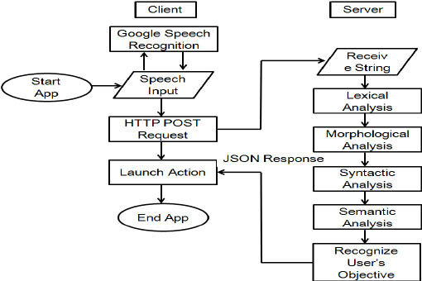

E-R DIAGRAM

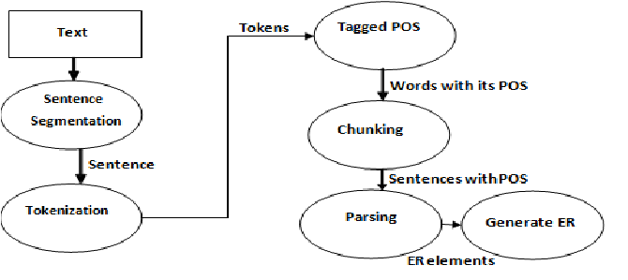

USE CASE DIAGAM:

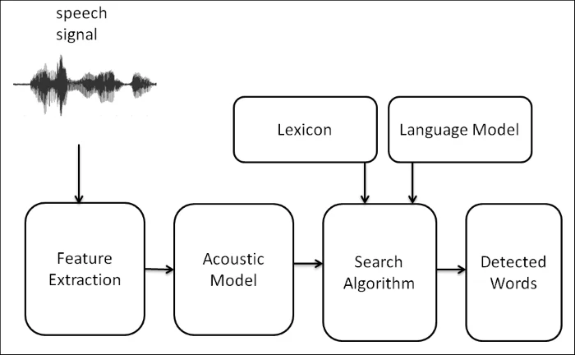

**FEASIBILITY STUDY**

A feasibility study for a language translator mini-project would typically involve assessing various aspects to determine if the project is viable and worth pursuing. Here's a breakdown of what such a study might entail:

* **Market Analysis:** Investigate the demand for language translation services. Are there potential users who would benefit from a language translator? What are their needs and preferences?

**Competitive Analysis:** Identify existing language translation tools and services. What features do they offer? How do they compare in terms of accuracy, speed, and usability?

**Technological Feasibility:** Assess the technical requirements for building a language translator. What algorithms and technologies are available for natural language processing and machine translation? Can these technologies be feasibly implemented within the scope of the mini-project?

**Resource Assessment:** Evaluate the resources needed to develop the language translator mini-project. This includes personnel (e.g., developers, linguists), technology (hardware, software), and time.

**Cost Analysis:** Estimate the costs associated with developing and maintaining the language translator. Consider factors such as development tools, licensing fees, hosting, and ongoing maintenance.

**Risk Assessment:** Identify potential risks and challenges that could affect the success of the project. This might include technical challenges, market competition, regulatory issues, or unforeseen obstacles.

**User Feedback:** Gather feedback from potential users to understand their needs and preferences regarding language translation tools. This could involve surveys, interviews, or usability testing.

**Legal and Ethical Considerations:** Consider any legal or ethical implications of building and deploying a language translator. This might include issues related to privacy, data security, and compliance with regulations such as GDPR.

**FACILITIES REQUIRED FOR PROPOSED WORK**

**Software Requirements:**

1. **Integrated Development Environment (IDE):**

- Choose an IDE suitable for the programming languages and technologies you'll be using. Popular choices include:

- Visual Studio Code

- IntelliJ IDEA

- Eclipse

2. **Programming Languages and Frameworks:**

- Depending on the chosen technology stack, you may need:

- Python for backend development and machine learning (for implementing translation algorithms).

- JavaScript/HTML/CSS for frontend development (for building the user interface).

- Frameworks and libraries such as Flask (for Python backend), React.js or Vue.js (for frontend), and TensorFlow or PyTorch (for machine learning).

3. **Version Control System:**

- Use a version control system like Git for managing project code and collaboration among team members.

- Platforms like GitHub or GitLab can be used for hosting repositories.

4. **Database Management System (DBMS):**

- Choose a DBMS for storing user data, translation history, etc. Options include:

- MySQL

- MongoDB (for NoSQL)

5. **APIs and Libraries:**

- Integrate APIs for language translation (e.g., Google Cloud Translation API, Microsoft Translator API) or use open-source libraries for implementing translation algorithms.

6. **Development Tools:**

- Tools for code debugging, profiling, and testing (e.g., PyCharm Debugger, Jest for JavaScript testing).

**Hardware Requirements:**

1. **Computing Resources:**

- High-performance computers or servers for development and testing.

- Cloud computing services like AWS, Google Cloud Platform, or Microsoft Azure can provide scalable computing resources.

2. **Storage:**

- Sufficient storage space for storing project code, datasets (if any), and user data.

- Consider both local storage and cloud storage options.

3. **Networking:**

- Stable internet connectivity for accessing online resources, collaboration, and testing APIs.

4. **End-user Devices:**

- Devices for testing the language translator system, including desktop computers, laptops.

5. **Backup and Security:**

- Implement backup solutions to prevent data loss.

- Ensure system security measures are in place to protect user data and system integrity.

6. **Documentation and Communication Tools:**

- Tools for project documentation (e.g., Google Docs, Confluence) and communication (e.g., Slack, Microsoft Teams) to facilitate collaboration among team members.

**CONCLUSION**

In conclusion, the development of a language translator presents an exciting opportunity to address the need for effective communication across language barriers. Through our proposed methodology and the identification of necessary software and hardware resources, we've outlined a structured approach to creating a functional and user-friendly language translation system.

By conducting thorough requirements analysis, designing an intuitive user interface, implementing robust translation algorithms, and rigorously testing the system, we aim to deliver a solution that meets the needs of users. Additionally, considerations such as scalability, security, and maintenance have been accounted for to ensure the long-term viability and success of the project.

The language translator has the potential to facilitate communication and collaboration across diverse linguistic backgrounds, thereby promoting inclusivity and accessibility in various domains, including education, business, and healthcare. Through continued refinement and innovation, we envision our language translator making a meaningful impact on cross-cultural communication and fostering greater understanding and cooperation in the global community.

In conclusion, we are committed to leveraging our expertise and resources to develop a high-quality language translator that not only addresses the challenges of language barriers but also contributes to the larger goals of innovation and social progress.

**REFERENCES**

1-Autenrieth, T. 2002. Heterosemie und Grammatikalisierung bei Modalpartikeln. Tübingen: Max Niemeyer.

2-Brinton, L.J. and E.C. Traugott. 2005. Lexicalization and Language Change. Cambridge: Cambridge University Press.

3-Burkhardt, A. 1995. Zur Übersetzbarkeit von Abtönungspartikeln (on the translatability of modal particles). Zeitschrift für Germanistische Linguistik, 23:2. 172-201.

4- Connolly, J.H., A. Chamberlain and I.W. Phillips. 2008. An Approach to Context in Human-Computer Communication. Semiotica, 169. 45-70.

5-Diewald, G. 2002. A Model for Relevant Types of Contexts in Grammaticalization. In: I. Wischer and G. Diewald (eds), New Reflections on Grammaticalization. Amsterdam: John Benjamins. 103- 120.

6-Diewald, G. 2007. Abtönungspartikel (downtoning particles). In: L. Hoffmann (ed.), Handbuch der Deutschen Wortarten (handbook of German word classes). Berlin: Walter de Gruyter. 117-141.

7-Hoffmann (ed.), Handbuch der Deutschen Wortarten (handbook of German word classes). Berlin: Walter de Gruyter. 117-141.

8- Feyrer, C. 1998. Modalität in Kontrast (modality in contrast). Frankfurt/Main: Peter Lang.

9- Franck, D. 1980. Grammatik und Konversation (grammar and conversation). Königstein/Taunus: Scriptor.

10- Goodwin, C. and A. Duranti. 1992. Rethinking Context: An Introduction. In: A. Duranti and C. Goodwin (eds), Rethinking Context: Language as An Interactive Phenomenon. Cambridge: Cambridge University Press. 1-42